|  |  |  |  |  |  |
| --- | --- | --- | --- | --- | --- |
|  | PRODUCTS Jim’s Purely Organic **803-622-6622** | **SIZE** | **PRICE** | **QUANTITY** | **TOTAL** |
| **AMENDMENTS** | | | | | |
|  | Purely Organic Mix | 23 lb | 25.00 |  |  |
|  | Purely Organic Mix | 45 lb | 45.00 |  |  |
|  | Alfalfa Meal or Pellets | 50 lb | 25.00 |  |  |
|  | Blood Meal | 40 lb | 45.00 |  |  |
|  | Bone Meal | 20 lb | 27.00 |  |  |
|  | Dolomitic Lime, Fine | 50 lb | 10.00 |  |  |
|  | Dolomitic Lime, Pelletized | 40 lb | 10.00 |  |  |
|  | Epsom Salts | 50 lb | 25.00 |  |  |
|  | Fish Meal | 50 lb | 65.00 |  |  |
|  | Gypsum (landplaster) 40# gran. or 50# fine | 50 lb | 19.00 |  |  |
|  | Milorganite | 50 lb | 19.00 |  |  |
|  | Natures Magic (Humus & Seaweed) | 1 qt | 20.00 |  |  |
|  | Liquid Seaweed and Fish Concentrate | 1 gal | 29.00 |  |  |
|  | Osmocote 15-9-12 plus minors (12-14 month) | 50 lb | 94.00 |  |  |
|  | 10% Chelated Iron (same as Sequestrene 330) | 5 lb | 45.00 |  |  |
|  | Sul-Po-Mag | 50 lb | 26.00 |  |  |
|  | Super Bloom 12-55-6 | 2 lb | 17.00 |  |  |
|  |  |  |  |  |  |
| **PESTICIDES** | | | | | |
|  | Avid (*for spider mites*) 1/3 tsp per gal | 8 oz | 100.00 |  |  |
|  | Bayer 3-in-1 | 1 qt | 23.00 |  |  |
|  | Botanigard ES | 1 qt | 85.00 |  |  |
|  | Propiconazole (generic Honor Guard) | 1 pt | 25.00 |  |  |
|  | Cleary’s 3336 | 1 qt | 65.00 |  |  |
|  | Conserve (spinosid) *leaf minors, thrips, worms* | 1 qt | 155.00 |  |  |
|  | Dithane M-45 (same as Manzate 75DF) | 1 lb | 19.00 |  |  |
|  | Eagle (*powdery mildew* fungicide) | 1 pt | 37.00 |  |  |
|  | Floramite (1-2 oz per 25 gal) (excellent *miticide*) | 8 oz | 110.00 |  |  |
|  | Mancozeb w/ zinc | 1pt | 22.00 |  |  |
|  | Parafine (horticultural oil) | 1 pt | 10.00 |  |  |
|  | Azoxystrobin 50WG (Heritage/Compass) | 1 lb | 105.00 |  |  |
|  | Manzate 75 DF | 6 lb | 39.00 |  |  |
|  | Merit 75% WSP 1 gram to 6 gal | 6.4 oz | 35.00 |  |  |
|  | Merit Granular ( *chilli thrips*) | 30 lb | 42.00 |  |  |
|  | Orthene 97 T&O (*general insecticide*) | .773 lb | 22.00 |  |  |
|  | *Tweak Acidifier (Indicate 5)* | 1 gal | 42.00 |  |  |
|  |  |  |  |  |  |
|  |  |  |  |  |  |
| **PROTECTIVE EQUIPMENT** | | | | | |
|  | Chemical Resistant Gloves (Small) (Medium) | 1 pair | 5.00 |  |  |
|  | CPV 15 Face Shield | 1 each | 25.00 |  |  |
|  | Spray suit w/hood M L XL XXL | 1 suit | 15.00 |  |  |
|  |  |  | SUBTOTAL: |  |  |

Page 2 of 2

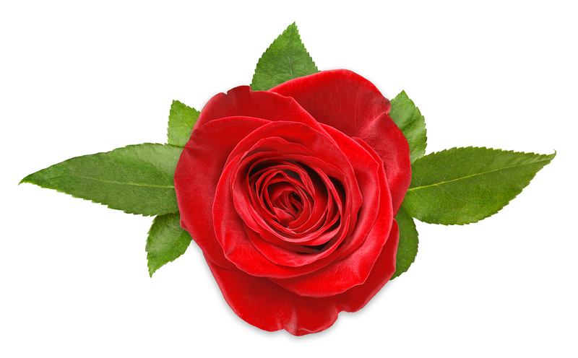

**Jim’s Purely Organic**

118 N. Wonder Dr.

Leesville SC 29070

803-622-6622 phone

Email order form to: jimyoung1129@gmail.com

|  |  |  |  |  |  |  |
| --- | --- | --- | --- | --- | --- | --- |
|  | | | | | | |
|  | | | | | | |
| **PESTICIDES** | | | | | | |
| **GENERIC** | | | **SIZE** | **PRICE** | **QUANTITY** | **TOTAL** |
|  | |  |  |  |  |  |
|  | | Macho 2F (Merit) 1/8 tsp per gal | 1 pt | 21.00 |  |  |
|  | | Minx 2 (Abamectin) 1/3 tsp per gal | 1 qt | 69.00 |  |  |
|  | | OHP 6672 50 wp (Clearys 3336) ¼ oz per 1 gal | 2 lb | 29.00 |  |  |
|  | | Qual-Pro (Honor Guard) 1/3 tsp per 1 gal  (Proplconazole 14.3) | 1 qt | 45.00 |  |  |
|  | |  |  |  |  |  |
|  | |  |  |  |  |  |
|  |  | |  |  |  |  |
|  |  | |  |  |  |  |
|  |  | |  |  |  |  |
| **ORGANIC** | | | **SIZE** | **PRICE** | **QUANTITY** | **TOTAL** |
|  | | Garden Friendly Fungicide | 1 pt | 16.00 |  |  |
|  | | Insecticidal Soap 1 – 2 oz per 1 gal | 1 pt | 15.00 |  |  |
|  | | Pyrethrin Natural 2 oz per 1 gal | 8 oz | 19.00 |  |  |
|  | | Triple Action Neem Oil Extract (insecticide, miticide, and scalicide) | 8 oz  1 pt | 14.00  20.00 |  |  |
|  | | Thuricide (worms only) 4 tsp per gal | 1 pt | 12.00 |  |  |
|  | | Conserve Naturalyte | 1pt | 17.00 |  |  |
|  | |  |  |  |  |  |
|  | |  |  |  |  |  |

***UPDATED: November 21, 2024* (Prices subject to change)**

SUBTOTAL:

|  |  |
| --- | --- |
| **TOTAL** |  |

Page 1 of 2