Deep South District Speakers for January 2018
Speaking Friday Night
Bob Martin, Vice President, American Rose Society
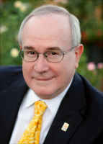
Bob Martin has been growing roses for more than 45 years. He and his wife Dona live in Escondido, California, where they maintain a rose garden of more than 520 roses of all types. He is an American Rose Society Master Rosarian, an Accredited Horticultural Judge and an Accredited Arrangements Judge.
Bob is the Vice President of the American Rose Society, the nation’s largest plant society, which is celebrating its 125th anniversary this year. In October,2018 he will automatically become the 56th President of the American Rose Society for a three-year term.
Bob is well known as a humorous and effective speaker and rose evangelist, having spoken at 24 American Rose Society national conventions, at district conventions in 13 of the 18 ARS districts and more than 250 times at rose societies and garden clubs throughout the U.S. Bob is also a prolific writer, having authored more than 600 published articles on roses. He is the National Editor of Horizon Roses, an annual review by the nation’s top exhibitors of new exhibition roses. Bob is also the author of the book “Showing Good Roses”, and maintains a website covering U.S. rose shows at www.roseshow.com. He was honored for his lifetime contribution to rose education as a 2009 recipient of the ARS Klima Medal.

Our Saturday Speakers:

Dr. Adam Dale

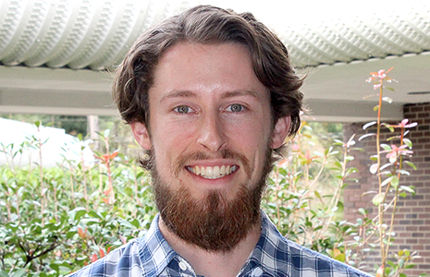
Dr. Adam Dale is an Assistant Professor, at the University of Florida, Gainesville. He has a Ph.D. Entomology (minor horticulture) from North Carolina State University and has a B.S. Biological Sciences – North Carolina State University. Since January 2016 – Present Assistant professor and extension specialist of turf grass and ornamental pest management. As the turf and ornamental entomologist, he is responsible for researching economically important pests of turf grass and ornamental plants, and disseminating the results through management recommendations to extension faculty across the state. The ultimate goal of my lab is to generate more sustainable, ecologically based management strategies that benefit the environment as well as the turf and ornamental industries

Christopher “Chris” VanCleave
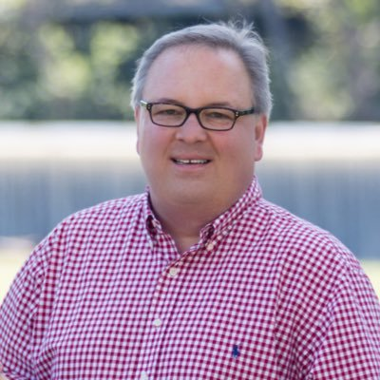
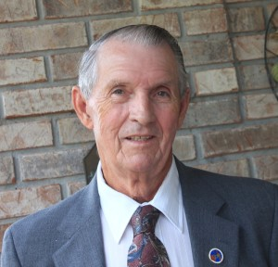
Christopher R. VanCleave, is nicknamed "The Redneck Rosarian”, Chris VanCleave is passionate about gardening and growing roses. He is an active member of the Birmingham chapter of the American Rose Society, serving two terms as President. In 2007, he created the Rose Chat Podcast which has reached over ¾ of a million listeners with news and information on growing on growing the world’s most beloved flower, the rose. He was a contributor to the 2015 Southern Living Gardening Book, has appeared on P. Allen Smith’s Garden Home television show and was featured in the June 2015 issue of Southern Living Magazine.

Richard J. Anthony
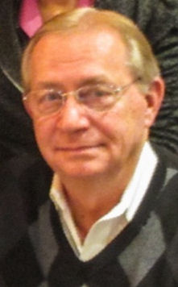
Richard J. Anthony, is the founder and managing principal of For Love of Roses LLC. He is a National level exhibitor with 126 Queens of Show to his credit after 14 years of exhibiting roses. He has accumulated 5 National Queens, 12 District Queens and 6 National Challenge Class Trophies plus over 900 trophies exhibiting his roses. He is also a 4- term member of the ARS Miniature & Miniflora Committee, a member of the ARS Classification Committee and a member of the ARS Consulting Rosarian Committee. Richard is also an accredited ARS Horticultural Rose Judge and a ARS Master Consulting Rosarian.
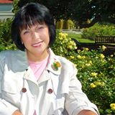
Hybridizing – 101; Richard's presentation is Hybridizing from an Exhibitor’s Perspective. It involves several different considerations all rolled into one. It is called a plan. Richard will discuss his plan which includes six (6) strategic elements four (4) of which are must haves and two (2) that he would like to have. His presentation will include photos of his 20 plus registered roses plus seedlings that are being evaluated for possible registration.

Ralph Stream, Director Deep South District
Ralph Stream is the current Director of the Deep South District of the American Rose Society. He has been growing roses for more than 40 years. He joined ARS in 1983 and has been a continuous member since, serving two districts, Colonial and Deep South. He co-founded two rose societies and served as president of three clubs, serving six two-year terms. He became a Consulting Rosarian in 1988 and an accredited horticultural judge in 1990. He was awarded two bronze medals, and in 2003, he was awarded the Outstanding Consulting Rosarian. He earned Master Consulting Rosarian in 2007. He has been awarded the Anita Smith Outstanding Service Award in 2010 and the Silver Medal in 2011. He has served as Vice Director 2007 – 2010 and became the Deep South Consultant Rosarian Program Chairman in 2010.

Pat Shanley, President American Rose Society
Pat Shanley, lives and gardens in Glen Cove, NY, where she grows approximately 250 roses. She is President of the American Rose Society. She is also an ARS Horticultural Judge; ARS Arrangement Judge; ARS Master Rosarian; Recipient of the ARS New York District Silver Honor Medal, Outstanding Judge and Outstanding Consulting Rosarian Awards; Recipient ARS Bronze Medal; Founding and Immediate Past President of the Manhattan Rose Society; Founding Chairman of the New York Metropolitan Rose Council; Chairman of the Great Rosarians of the World™ East (GROW™) Award Lectureship; Past Vice Chairman, Queens Botanical Garden Board of Trustees and Chairman of American Garden Rose Selections™ - the new national testing program for new rose varieties. Pat was the Guest Editor of the 2012 ARS Annual. She is also the co-editor and a contributing author of “The Sustainable Rose Garden - A Reader in Rose Culture” 2010, published by Newbury books, (an imprint of Casemate Publishers) which received the World Federation of Rose Societies Literary Award for 2012.

Sunday: Consulting Rosarian Class

Wayne Myers
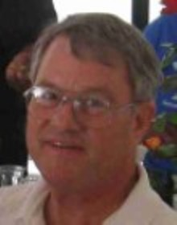
Wayne has been active in the Jacksonville Rose Society since 1990. He has written their newsletter’s rose-care column since 2009.
Wayne is an early adapter and disciple of “sustainable” rose growing.
He played a key role in the restoration of 2 sustainable rose gardens in Jacksonville: the Cummer Gardens’ roses and a neighborhood park in San Marco.
In 2001 Wayne planted and since then has maintained a no-spray rose garden at Orange Park [FL] United Methodist Church.
He has published rose articles in local, district, and national rose publications, having now won three Awards of Merit from the American Rose Society (ARS) and authored 15 pages in the 2016 “American Rose Annual.”

